SELECT COUNT(DISTINCT DRIVER_ID)CNT FROM PARTICIPATED A,ACCIDENT B WHERE A.REPORT_NUM=B.REPORT_NUM AND B.ACCIDENT_DATE LIKE '%08';

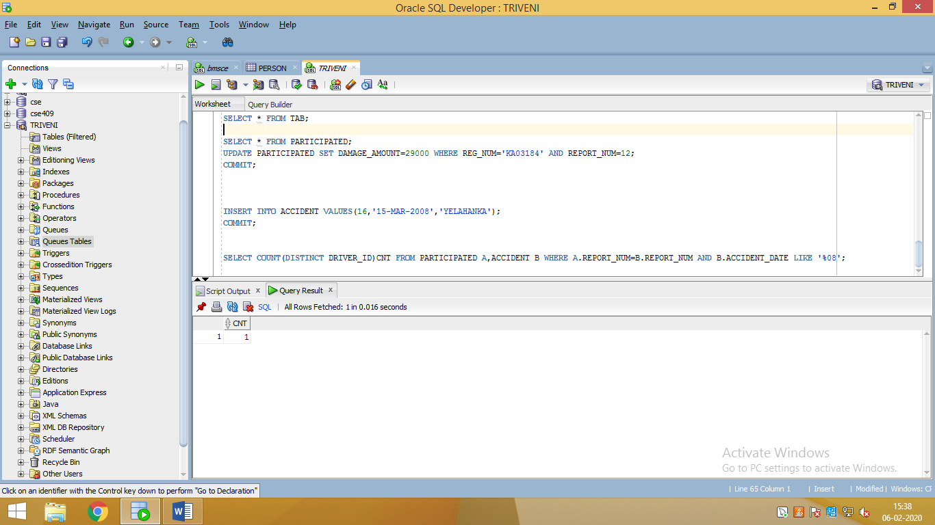

UPDATE PARTICIPATED SET DAMAGE_AMOUNT=29000 WHERE REG_NUM='KA03184' AND REPORT_NUM=12; 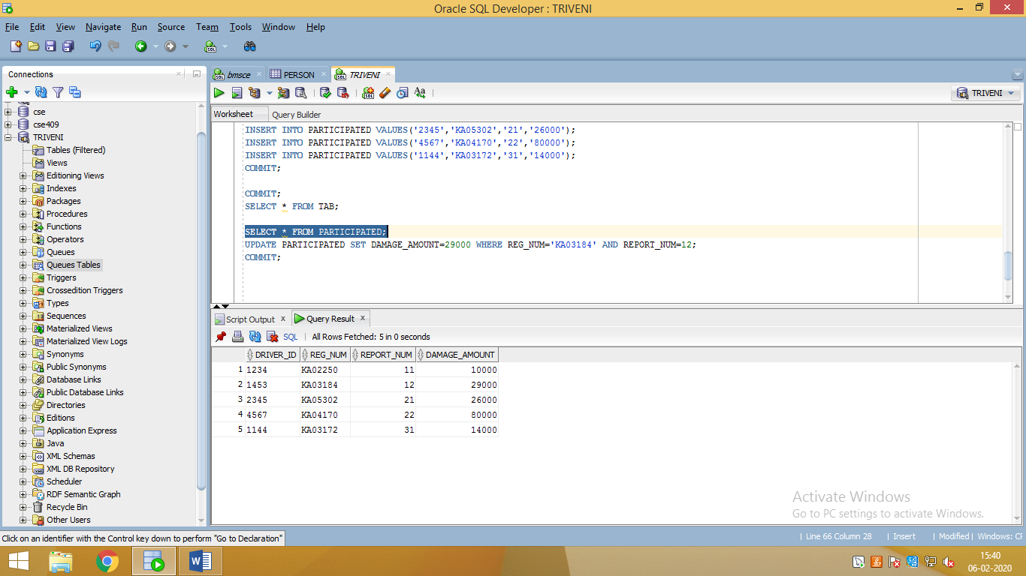

SELECT COUNT(REPORT_NUM)CNT FROM CAR C,PARTICIPATED P WHERE C.REG_NUM=P.REG_NUM AND MODEL='LANCER';

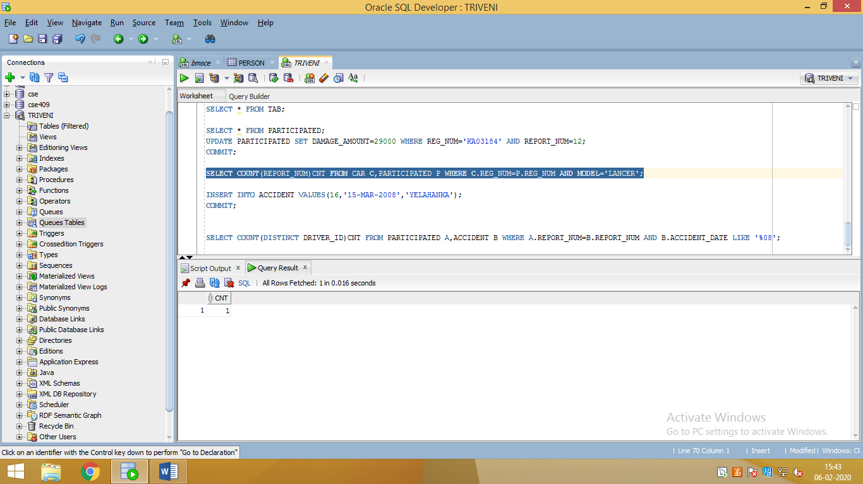

SELECT * FROM PARTICIPATED ORDER BY DAMAGE_AMOUNT DESC;

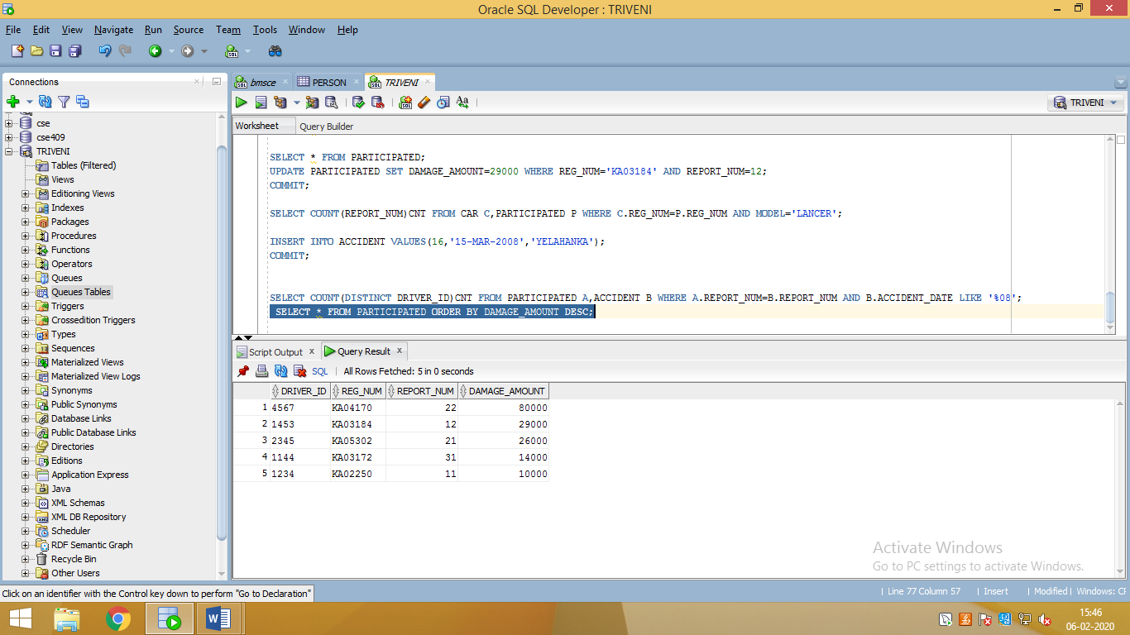

SELECT AVG(DAMAGE_AMOUNT) FROM PARTICIPATED;

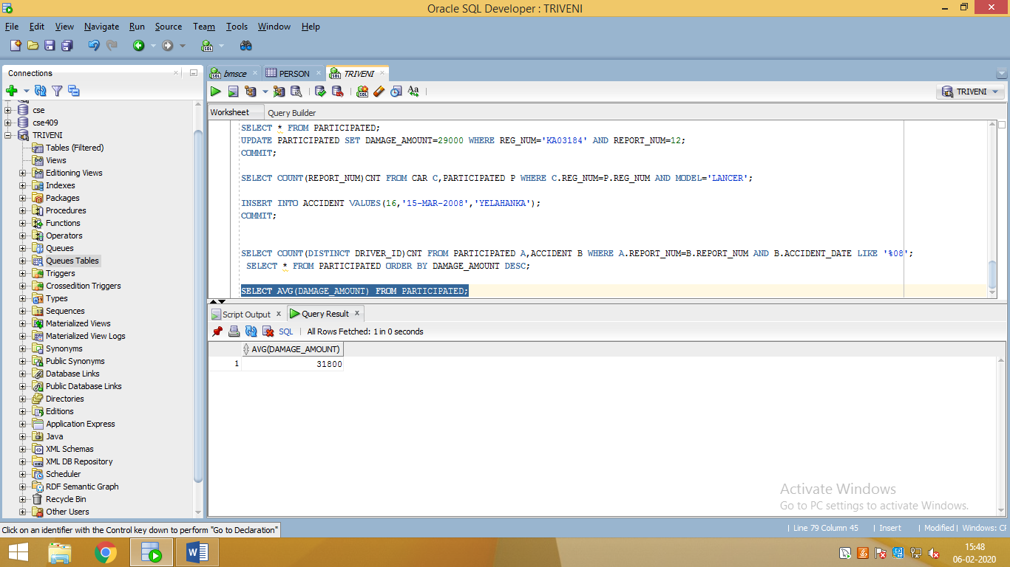

DELETE FROM PARTICIPATED WHERE DAMAGE_AMOUNT>=27000;

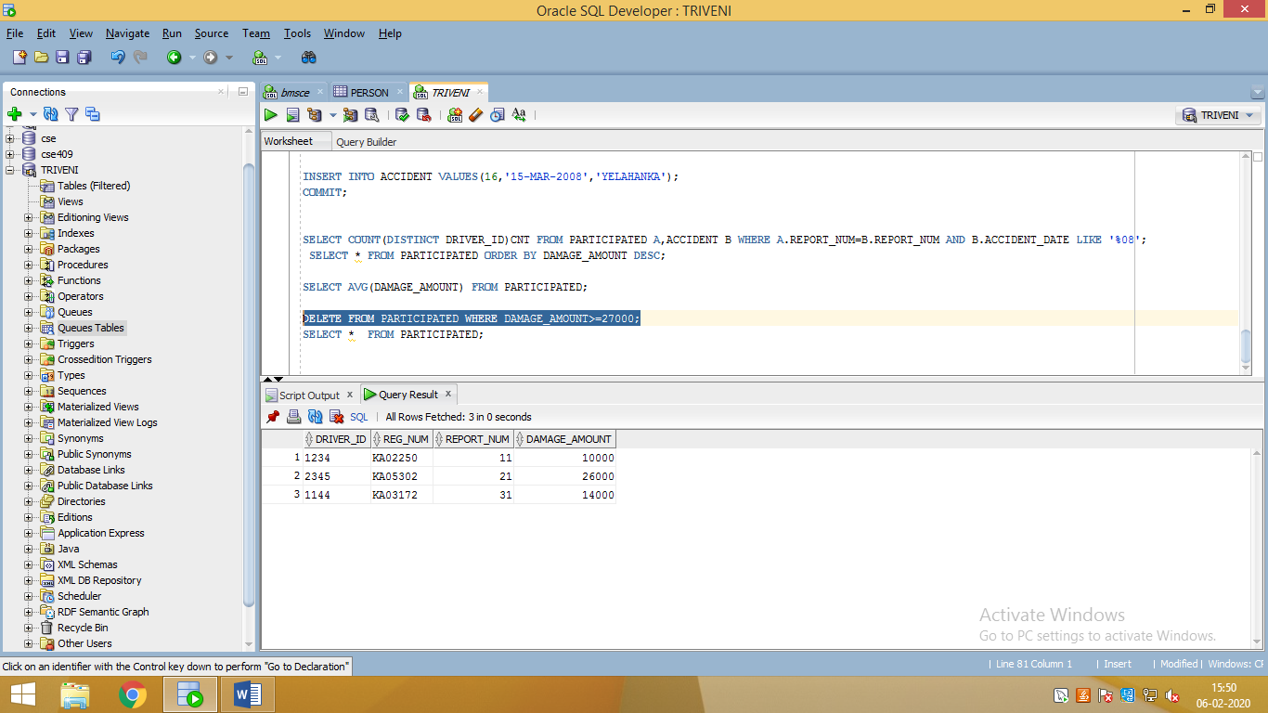

SELECT MAX(DAMAGE_AMOUNT) FROM PARTICIPATED;

